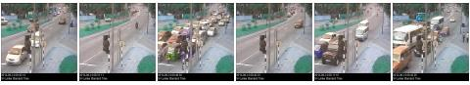

Learning cycle 1

Learning cycle 2

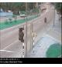

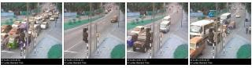

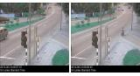

With five input files (three layers putting same inputs)

Getting the first 350 frames

SF=0.6

Iterations =400

Hit threshold =0

Same Data single cycle

Getting only the first 350 frames

SF=0.88

Iterations =1000

Hit threshold = 0

Learning cycle 2

